

**2023**

**Carve Out Benefits**

**Talking Points**

# Table of Contents:

1. Transportation (e.g., Gurney Level Transportation) Page 2

2. Items not reflected in EOC or Benefit Grid Page 2 &3

Member Plan Name

**This document is to service as a guide. Providers/venders are responsible to check member eligibility as well as reference the member specific Evidence of Coverage and Benefit Grid for coverage:**

* **The Member’s Evidence of Coverage (EOC) - *Chapter 4 Medical Benefits Chart*** 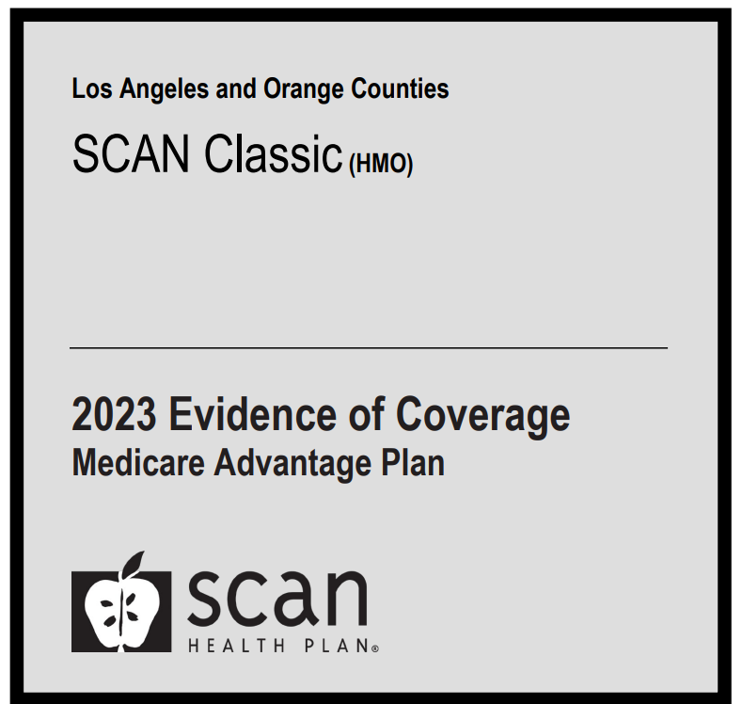
* **Benefit Grid by Year under Member’s Specific Plan (i.e., Balance, Classic, Connections, Embrace)**

1. **Transportation**

|  |
| --- |
| **Guidance on Next Steps for Provider to Take** |
| 1. Providers must check the member specific Evidence of Coverage (EOC) and Benefit Grid for transportation coverage. 2. SCAN is responsible for routine transportation benefits through SafeRide. Gurney level transportation **may not be covered** under certain SCAN plans. If member’s benefits (e.g., Classic Riverside) do not reflect gurney level transportation embedded in their routine transportation benefit, please note the following:    1. Gurney level transportation is not considered routine transportation; therefore, these services are not carved out to SCAN.    2. The member’s EOC states under Chapter 4 Medical Benefits Chart in **Ambulance section** “non-emergency transportation by ambulance is appropriate if it is documented that the member’s condition is such that other means of transportation could endanger the person’s health and that transportation by ambulance is medically required”. 3. Medicare covers non-emergency transportation only when the member’s condition is such that other means of transportation would be contraindicated or would endanger the member’s health. No reimbursement should be made if a different means of transportation, other than an ambulance, could be used without endangering the individual’s health, whether or not such other transportation is actually available.   Therefore, the delegated Medical Group (MG**) must make this assessment** to determine if the member’s condition meets the above qualifications.   * 1. If member’s condition qualifies then MG will need to provide an authorization to their contracted ambulance vendor   2. MG would be financially responsible for these charges.   3. Member could potentially have an ambulance copay for each way (refer to member specific EOC).  1. MG should also assess if visit could be rendered through their Telehealth instead an in person visit; therefore, gurney level transportation is not needed. |

1. **Items not Reflected in EOC or Benefit Grid**

|  |
| --- |
| **Guidance on Next Steps for Provider to Take** |
| 1. Providers must check the member specific Evidence of Coverage (EOC) and Benefit Grid for specific coverage on services. 2. If not referenced in EOC or Benefit Grid, refer to SCAN Provider Operations Manual (POM)under Chapter 6: Utilization Management in *Prior Authorization* section. The standard for determining coverage would be to use the hierarchy noted below that is outlined in this section of the SCAN POM.    * SCAN typically delegates the responsibility for prior authorizations to its delegated entities, depending on the Provider’s contract with SCAN. An exception is Medi-Cal only benefits, where SCAN may require prior authorization    * Prior authorization is never required for Emergency Services, including behavioral health services necessary to screen and stabilize Members.    * Prior authorization is always required for planned out of area services that are not Urgent or Emergent.    * Delegated Entities must follow Medicare Guidelines including, but not limited to:      1. Medicare National Coverage Determinations (NCD)      2. Medicare Local Coverage Decisions (LCD)      3. Local Coverage Articles (LCAs) (Active/Retired)      4. Medicare Manuals         1. Medicare Managed Care Manual         2. Medicare Benefit Policy Manual         3. Program Integrity Manual         4. Medicare Claims Processing Manual    * In the absence of Medicare guidelines:      1. Nationally recognized evidenced based clinical practice guidelines (e.g., Hypertension – JNC 8; Diabetes – ADA; Standards of Care; CHF - ACCF/AHA Guideline; COPD – Gold Pocket Guide; Hepatitis C: AASLD/IDSA guidelines, Dementia – AGS guideline, 2016 CDC Guideline for Prescribing Opioids for Chronic Pain, etc.) National Comprehensive Cancer Network (NCCN).    * SCAN Medical Policy ([medicalpolicy@scanhealthplan.com](mailto:medicalpolicy@scanhealthplan.com))      1. Nationally recognized evidence-based criteria (e.g., InterQual® or Milliman Care Guidelines) in conjunction with the clinical judgement of a qualified health professional. 3. **Delegated entities may request coverage guidance from SCAN by sending an email to medicalpolicy@scanhealthplan.com.** |